Project 4

Annie Thwing

December 11, 2017

**Analysis Plan**

The objective of aim 1 is to evaluate longitudinal associations between markers of peripheral inflammation, cognition and brain structure. We are going to do this by dividing up aim 1 into two parts; a and b. For Aim 1a, we are interested in determining whether higher levels of peripheral inflammation predict declines in memory consolidation and AD-signature cortical thickness. For Aim 1b, we are interested in determining whether increases in peripheral inflammatory markers are correlated with declines in memory consolidation and AD-signature cortical thickness.

Our analysis plan for Aim 1a will be to fit linear regression models for combinations of each of our two outcomes with each of the 6 cytokine’s and chemokine’s that are markers of peripheral inflammation. There are 6 cytokines and chemokine’s that will be considered, and a model will be fit for each one, for each outcome, the primary explanatory variable being the value of each cytokine or chemokine at baseline. This will result in 12 models fit, with each model adjusting for age, sex, the level of the outcome at baseline and principal components explaining at least 80% of the rest of the variability in our data. Our outcomes will be 1-year change in memory (as measured by CVLT score), and 1-year change in cortical thickness. We will additionally fit a model for each outcome for all of the baseline values of the cytokines and chemokine’s at once, in order to see whether associations of individual cytokines or chemokine’s with the outcome are diluted in the presence of other markers that may have stronger associations. Finally, all of our significance testing will be done at an α-level of 0.01, as we feel that a Bonferroni adjustment (.05/14) would be too harsh given correlations in our models. The principal components will be chosen by running a PCA on measures of cardiovascular health, BMI, high cholesterol, anti-inflammatory drug medications to find the linear combination of them which will account for 80% of the variability in our data, these are the ones which will be included.

Our analysis plan for Aim 1b will be very similar to Aim 1a. We will also fit linear regression models for each cytokine and chemokine, for each outcome. Our two outcomes will also be 1-year change in memory and 1-year change in cortical thickness. We will again fit 12 models, one for each cytokine or chemokine with each outcome. The primary explanatory variable for each of these models will be the change in the cytokine or chemokine’s levels over 1 year. Covariates that we will be adjusting for in each model will be the outcome’s level at baseline, age, sex and principal components that can explain at least 80% of the variation in our dataset, which will be found in the same way as Aim 1a. We will additionally fit a model for each outcome including the 1-year change values for all of the cytokines and chemokines at once in order to see whether associations of each with the outcome hold in the presence of other markers they may be correlated with. Finally, all of our significance testing will be done at an α-level of 0.01, as we feel that a Bonferroni adjustment (.05/14) would be too harsh given correlations in our models.

The objective for Aim 2 is to examine how the markers of peripheral inflammation impact the relationship between the pathology of Alzheimer’s disease and the clinical progression of amnestic mild cognitive impairment. This objective will be achieved by dividing aim 2 up into two parts; a and b. For Aim 2a we are interested in determining whether the presence of significant amyloid deposition and high levels of peripheral inflammatory markers are the strongest predictors of cognitive decline. For Aim 2b we are interested in determining whether the presence of significant amyloid deposition and high levels of peripheral inflammatory markers are the strongest predictors of lower levels of Ad-signature cortical thickness.

Our analysis plan for Aim 2a will be to fit a linear regression model of change in memory on each of our markers of peripheral inflammation (cytokines and chemokines, there are 6 total). Our outcome for Aim 2a is 1-year change in memory; the primary explanatory variables will be amyloid deposition, each cytokine/chemokine level at baseline and an interaction between amyloid deposition and the cytokine/chemokine. Additionally we will be including age, sex, the baseline value of the outcome and principal components that explain up to 80% of the variability in our dataset as covariates, as discussed in Aim 1a. Finally, all of our significance testing will be done at an α-level of 0.01, as we feel that a Bonferroni adjustment (.05/14) would be too harsh given correlations in our models.

Our analysis plan for Aim 2b will be to fit a linear regression model of change in cortical thickness on each of our markers of peripheral inflammation (cytokines and chemokines, there are 6 total). Our outcome for Aim 2b is 1-year change in cortical thickness, the primary explanatory variables will be amyloid deposition, each cytokine/chemokine level at baseline and an interaction between amyloid deposition and the cytokine/chemokine. Additionally we will be including age, sex, the baseline value of the outcome and principal components that explain up to 80% of the variability in our dataset as covariates, as discussed in Aim 1a. Finally, all of our significance testing will be done at an α-level of 0.01, as we felt that a Bonferroni adjustment (.05/14) would be too harsh given correlations in our models.

**Sample Size and Power Calculations**

All sample size and power calculations were done using version 3.1.9.3 of G*Power (download link in G*power section).

The suggested sample size for Aim 1 of 175 subjects yielded 53.4% power to detect a significant effect given that one was present, at an α error probability of 0.01 and hoping to detect correlations of 0.2. Further computation using the Correlation: Bivariate Normal Model suggested a total sample size of 287, in order to achieve 80% power at an α error probability of 0.01. With an expected 10% loss at follow up, this would mean recruiting 316 subjects for the study.

For Aim 2 we determined that the minimum effect size we are able to detect using the same sample size of 287 participants (assuming the 10% dropout), and assuming a dichotomizing of amyloid deposition into high/low groups at the median. At a power of 80% and an α error probability of 0.01, this sample size only allowed for a detectable effect size that was greater than or equal to 0.408, as can be seen in Figure 1. Finally it was determined that in order to get an effect size of 0.408, the correlation coefficients needed to be within 0.38 of each other. This was also calculated in G*Plot using their “Determine” tool for effect size.

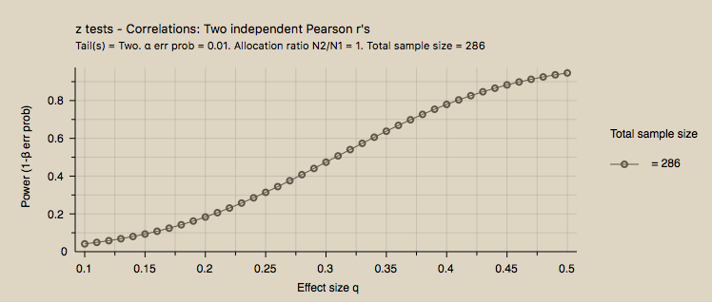

Figure

**G*Power**: http://www.gpower.hhu.de/en.html